Copernicus Marine Ocean Dataset (NetCDF) – Team Explanation
What is this dataset?
The file we downloaded is a Copernicus Marine Global Ocean Physical Analysis and Forecast dataset. It is a scientific dataset that contains real measurements and model-based predictions of the ocean for a selected region (India's EEZ: 68°E–95°E, 5°N–22°N).
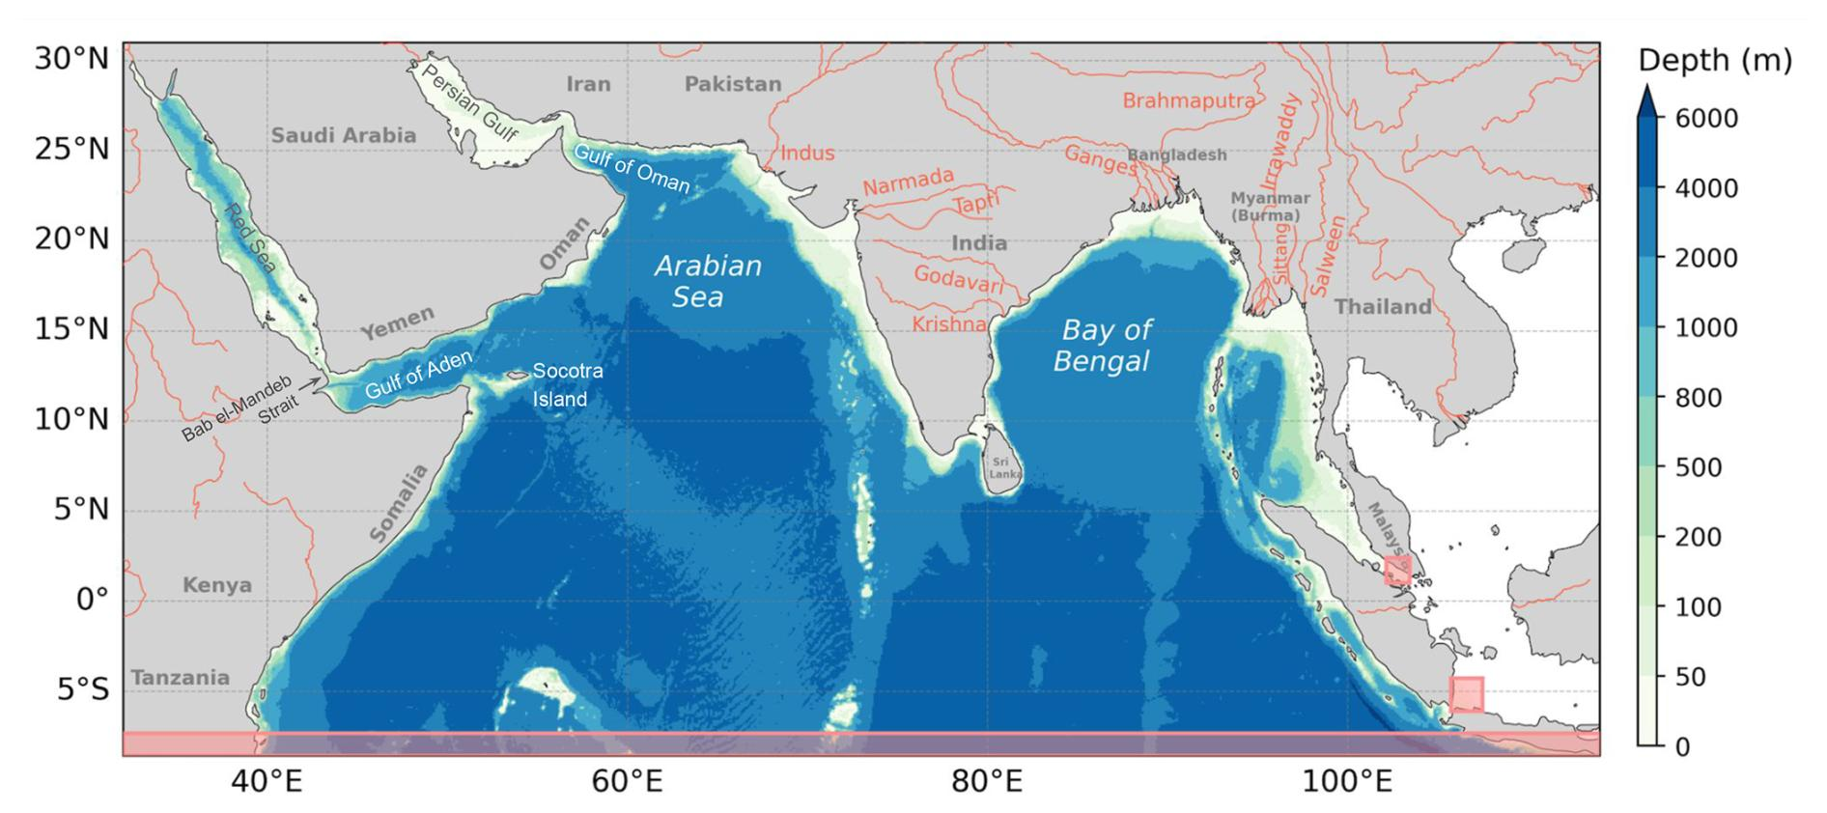
Unlike a normal database, this data is stored in a NetCDF (.nc) file, which is the international standard used by INCOIS, NOAA, NASA, and Copernicus for storing multidimensional environmental data.
DATASET_GUIDE.md
Why NetCDF instead of MySQL?
Think of the ocean as a 3D cube that changes every day.
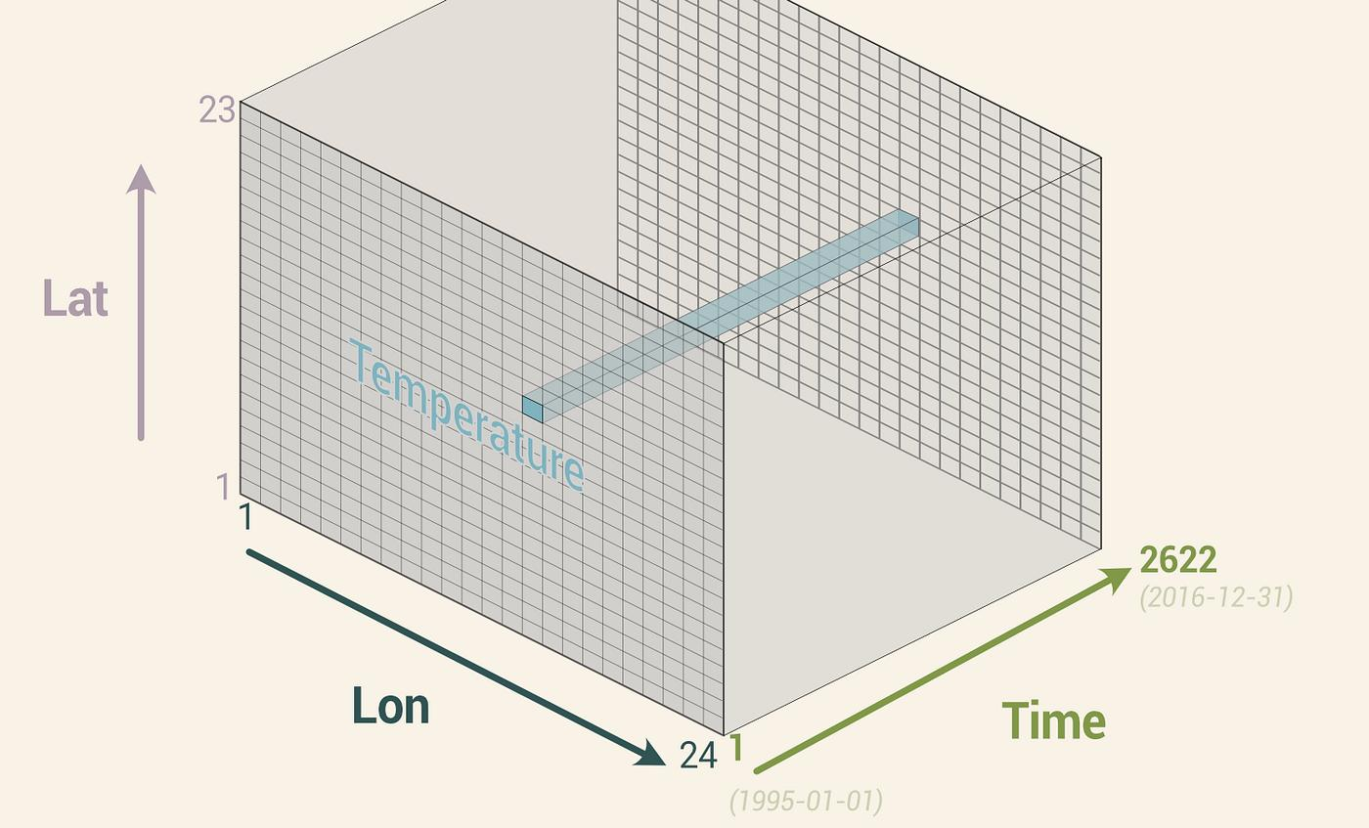
A normal SQL table cannot efficiently store millions of values across:
- Time
- Latitude
- Longitude
- Depth
NetCDF is designed specifically for this kind of scientific data.
MySQL | NetCDF
Stores rows | Stores multidimensional grids
Query using SQL | Query using Python (xarray)
Good for users/orders | Good for weather and ocean data
What exactly is inside the .nc file?
The dataset is organized into Dimensions, Coordinates, and Variables.
1. Dimensions (The Axes)
These define the structure of the data.
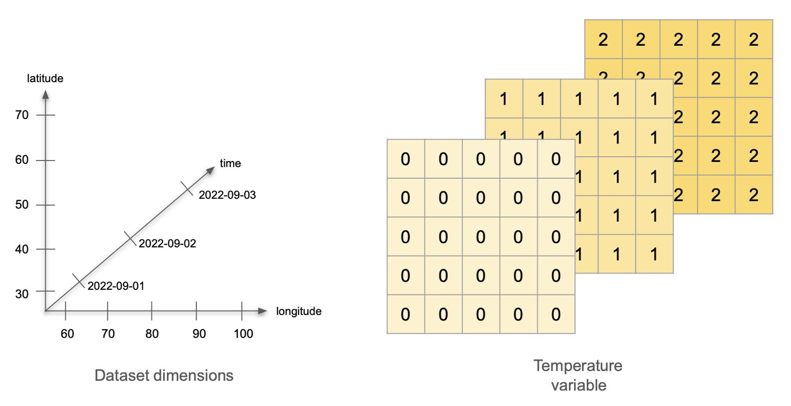
Dimension | Meaning
Time | Different dates and forecast times
Depth | Surface, 10 m, 20 m, 50 m... deep ocean
Latitude | North-South position
Longitude | East-West position
Example:
Time : 31 Aug 2026
Latitude : 18.5°N
Longitude : 72.8°E
Depth : 100 m
These four values point to one exact location inside the ocean.
2. Variables (The Actual Ocean Data)
At every point in that 4D grid, the dataset stores multiple ocean properties.
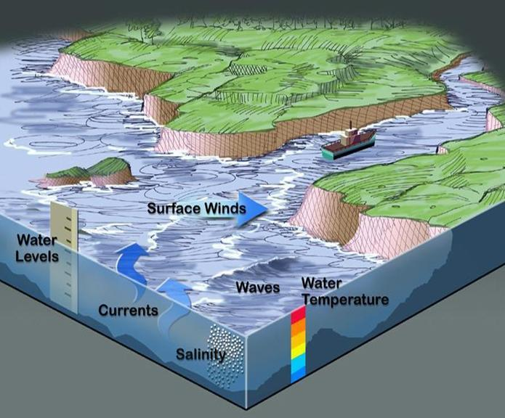
A. Temperature (thetao → temperature)
- Water temperature at different depths.
- Unit: °C
Example:
Depth | Temperature
0 m | 29°C
50 m | 26°C
100 m | 22°C
Our project uses this to create temperature heatmaps.
B. Salinity (so)
- Amount of dissolved salt.
- Unit: Practical Salinity Units (PSU).
Example:
Depth | Salinity
0 m | 34 PSU
100 m | 35 PSU
Useful for understanding ocean density and water movement.
C. East-West Current (uo)
This tells how fast water moves East or West.
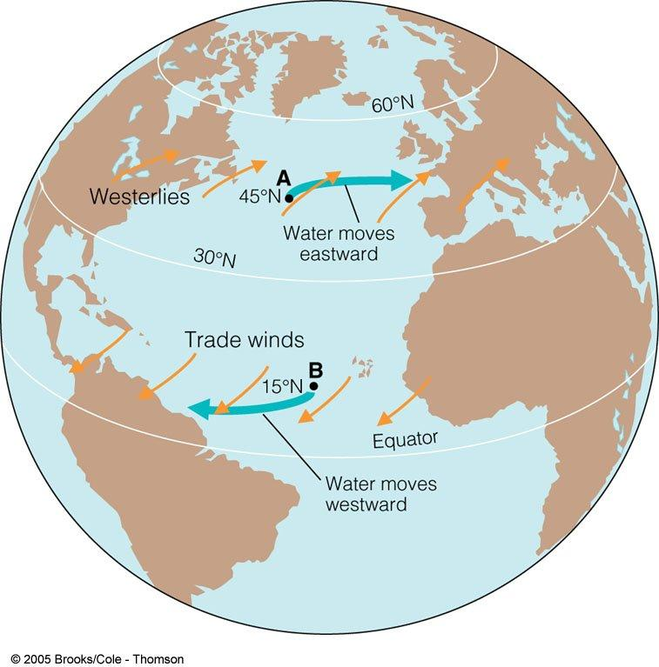
- Positive = East
- Negative = West
Example:
0.8 m/s East
D. North-South Current (vo)
This tells how fast water moves North or South.
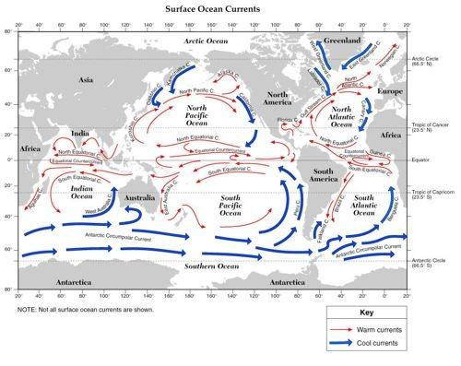
Together:
- uo
- vo
create a complete current vector.
Our frontend can draw arrows showing ocean movement.
E. Sea Surface Height
This measures the height of the ocean surface.
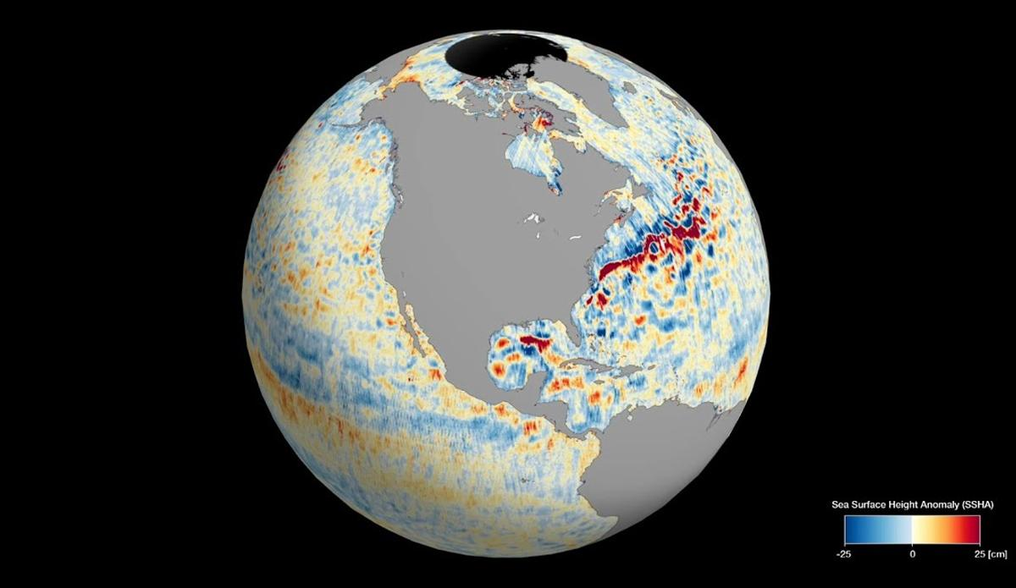
Useful for:
- Ocean circulation
- Eddy detection
- Forecasting
F. Mixed Layer Depth
This indicates how deep the ocean's surface layer mixes.
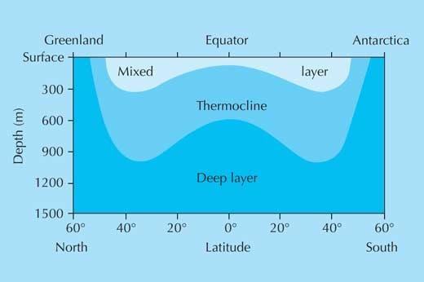
Important for:
- Weather
- Marine biology
- Ocean forecasting
DATASET_GUIDE.md
How the data is organized
Imagine this as an enormous Excel sheet with four dimensions.
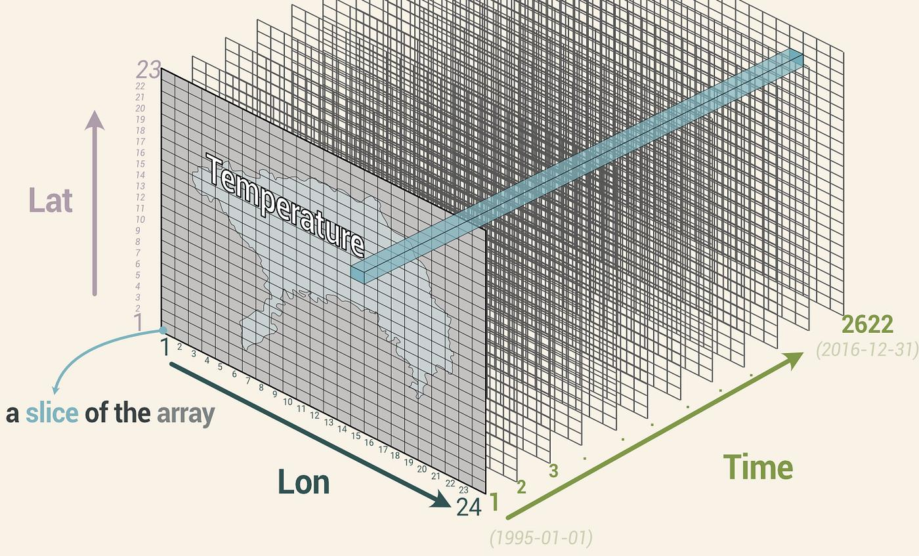
Instead of:
City | Temperature
We have:
Time | Latitude | Longitude | Depth | Temperature
31 Aug | 18.5° | 72.8° | 0 m | 29°C
31 Aug | 18.5° | 72.8° | 50 m | 26°C
31 Aug | 18.5° | 72.8° | 100 m | 22°C
Now imagine this repeated for thousands of locations.
How our backend uses it
The project already has a schema-driven ingestion system.

When someone clicks a location:
- Backend receives coordinates.
- Opens the .nc file using xarray.
- Reads temperature, salinity, and currents.
- Sends the values to the frontend as JSON.
The guide notes that as long as the dataset follows CF-style dimensions (time, depth, lat, lon), only configuration paths need changing—not the frontend or API routes.
DATASET_GUIDE.md
Example: Real Query
Suppose the user clicks Mumbai.
Input:
Latitude : 18.9°N
Longitude: 72.8°E
Depth : 100 m
Time : Today
Backend reads:
temperature = ds.temperature.sel(
lat=18.9,
lon=72.8,
depth=100
)
Output:
{
"temperature": 24.3,
"salinity": 35.1,
"current_speed": 0.7
}
The frontend immediately displays this on the dashboard.
Why this dataset is valuable for SIH
Instead of using randomly generated values, we're using real oceanographic data similar to what INCOIS operational systems work with.
Benefits:
- Real temperature profiles
- Real salinity distribution
- Real ocean current vectors
- Multiple depth levels
- Forecast-ready data
- Compatible with our existing backend architecture

We downloaded a real Copernicus Marine NetCDF dataset covering India's ocean region. The file stores four-dimensional ocean information across time, latitude, longitude, and depth. At every point, it contains variables like temperature, salinity, east-west and north-south currents, sea surface height, and mixed-layer depth. Our FastAPI backend reads this file using xarray, extracts values for any selected location, and sends them to the frontend. This lets us replace synthetic data with real INCOIS-grade ocean information without changing our application architecture.

